Test Data for Prediction
Age | Glucose | BloodPressure | Insulin | BMI | SkinThickness | DPF | Expected Outcome
28 | 100 | 76 | 85 | 24.0 | 29 | 0.5 | Non-Diabetic
50 | 190 | 85 | 400 | 38.2 | 43 | 1.3 | Diabetic
35 | 120 | 78 | 130 | 27.5 | 32 | 0.8 | Non-Diabetic
60 | 210 | 90 | 600 | 41.0 | 45 | 1.7 | Diabetic
40 | 115 | 80 | 110 | 25.5 | 30 | 0.6 | Non-Diabetic

Borderline Cases for Prediction
Age | Glucose | BloodPressure | Insulin | BMI | SkinThickness | DPF | Expected Outcome
45 | 125 | 82 | 130 | 29.5 | 32 | 0.9 | Borderline (Pre-Diabetic / Uncertain)
50 | 140 | 85 | 200 | 30.0 | 35 | 1.0 | Borderline (Might be Diabetic)

Age | Glucose | BloodPressure | Insulin | BMI | SkinThickness | DPF | Expected Outcome
42 | 126 | 80 | 140 | 28.5 | 31 | 0.9 | Borderline (Could be Pre-Diabetic or Diabetic)
55 | 135 | 85 | 180 | 29.8 | 34 | 1.1 | Borderline (Leaning Toward Diabetic)

Diabetic Cases
Age | Glucose | Blood Pressure | Insulin | BMI | Skin Thickness | Diabetes Pedigree Function (DPF)
50 | 180 | 90 | 150 | 32.5 | 35 | 1.2
45 | 200 | 85 | 180 | 30.0 | 40 | 0.9
55 | 160 | 95 | 130 | 34.0 | 25 | 0.8
Non-Diabetic Cases
Age | Glucose | Blood Pressure | Insulin | BMI | Skin Thickness | Diabetes Pedigree Function (DPF)
30 | 90 | 75 | 70 | 24.0 | 20 | 0.5
35 | 85 | 80 | 60 | 22.5 | 18 | 0.4
40 | 100 | 78 | 90 | 25.0 | 23 | 0.6

pima data only enough?
ChatGPT said:
Yes, the Pima Indians Diabetes Dataset is one of the most widely used and well-structured datasets for diabetes prediction, so it can be enough for testing your model, but with some limitations.
✅ Why Pima Data is Useful?
- Comprehensive Features: It includes medically relevant attributes like glucose, BMI, insulin, blood pressure, and diabetes pedigree function.
- Widely Used: Many machine learning studies have used this dataset, so there are benchmarks for comparison.
- Good for Initial Validation: It helps you check whether your model performs reasonably well on a real medical dataset.
- • 0.50 - 0.59 → Pre-Diabetes (Borderline Negative)
- • 0.60+ → Diabetes (Positive)

Threshold 0.45

Age | Glucose | BloodPressure | Insulin | BMI | SkinThickness | DPF | Outcome

45 | 180 | 85 | 200 | 35.4 | 32 | 0.8 | 1 (Diabetic)

50 | 160 | 90 | 180 | 30.2 | 28 | 1.2 | 1 (Diabetic)

35 | 140 | 75 | 120 | 28.6 | 25 | 0.9 | 1 (Diabetic)

29 | 130 | 80 | 100 | 24.5 | 22 | 0.6 | 0 (Non-Diabetic)

40 | 110 | 70 | 85 | 22.3 | 20 | 0.5 | 0 (Non-Diabetic)

25 | 100 | 65 | 60 | 21.1 | 18 | 0.4 | 0 (Non-Diabetic)

60 | 190 | 95 | 250 | 37.8 | 35 | 1.5 | 1 (Diabetic)

55 | 170 | 85 | 200 | 32.5 | 30 | 1.1 | 1 (Diabetic)

38 | 150 | 80 | 140 | 29.3 | 27 | 0.7 | 1 (Diabetic)

28 | 120 | 75 | 90 | 23.1 | 21 | 0.5 | 0 (Non-Diabetic)

48 | 130 | 78 | 110 | 25.9 | 24 | 0.6 | 0 (Non-Diabetic)

33 | 105 | 68 | 70 | 22.7 | 19 | 0.5 | 0 (Non-Diabetic)

65 | 200 | 100 | 300 | 40.0 | 38 | 1.8 | 1 (Diabetic)

58 | 175 | 88 | 210 | 34.2 | 31 | 1.3 | 1 (Diabetic)

22 | 90 | 60 | 50 | 20.3 | 16 | 0.3 | 0 (Non-Diabetic)

42 | 135 | 76 | 105 | 26.7 | 23 | 0.7 | 0 (Non-Diabetic)

Age | Glucose | BloodPressure | Insulin | BMI | SkinThickness | DPF | Outcome

52 | 185 | 88 | 230 | 36.5 | 33 | 1.3 | 1 (Diabetic)

47 | 160 | 82 | 190 | 31.7 | 28 | 1.0 | 1 (Diabetic)

30 | 128 | 74 | 95 | 24.9 | 22 | 0.6 | 0 (Non-Diabetic)

41 | 115 | 72 | 80 | 23.5 | 21 | 0.5 | 0 (Non-Diabetic)

23 | 98 | 64 | 55 | 20.7 | 17 | 0.4 | 0 (Non-Diabetic)

61 | 195 | 98 | 280 | 39.2 | 37 | 1.6 | 1 (Diabetic)

54 | 178 | 90 | 215 | 33.8 | 29 | 1.2 | 1 (Diabetic)

39 | 153 | 85 | 140 | 29.0 | 27 | 0.9 | 1 (Diabetic)

27 | 118 | 76 | 100 | 22.9 | 20 | 0.5 | 0 (Non-Diabetic)

45 | 137 | 80 | 108 | 26.5 | 24 | 0.7 | 0 (Non-Diabetic)

32 | 110 | 70 | 75 | 21.5 | 18 | 0.4 | 0 (Non-Diabetic)

Diabetic Cases (Confirmed Type 2 Diabetes)
Age | Glucose | BloodPressure | Insulin | BMI | SkinThickness | DPF | Outcome
55 | 190 | 95 | 250 | 38.5 | 36 | 1.4 | 1 (Diabetic)
60 | 200 | 100 | 280 | 40.2 | 38 | 1.6 | 1 (Diabetic)
50 | 185 | 92 | 230 | 36.8 | 35 | 1.3 | 1 (Diabetic)
58 | 195 | 98 | 270 | 39.5 | 37 | 1.5 | 1 (Diabetic)
65 | 210 | 105 | 300 | 42.0 | 40 | 1.7 | 1 (Diabetic)
Non-Diabetic Cases (Clearly Normal)
Age | Glucose | BloodPressure | Insulin | BMI | SkinThickness | DPF | Outcome
25 | 95 | 65 | 50 | 20.5 | 15 | 0.4 | 0 (Non-Diabetic)
30 | 100 | 70 | 60 | 22.0 | 18 | 0.5 | 0 (Non-Diabetic)
35 | 105 | 75 | 70 | 23.5 | 20 | 0.6 | 0 (Non-Diabetic)
40 | 110 | 78 | 80 | 24.8 | 22 | 0.7 | 0 (Non-Diabetic)
45 | 115 | 80 | 90 | 26.0 | 24 | 0.8 | 0 (Non-Diabetic)
Here are two medically accurate cases, one for diabetes and one for non-diabetes:
Diabetic Case (Confirmed Type 2 Diabetes)
Age | Glucose | BloodPressure | Insulin | BMI | SkinThickness | DPF | Outcome
55 | 195 | 98 | 280 | 39.5 | 37 | 1.5 | 1 (Diabetic)
- Glucose = 195 mg/dL → Well above the ≥126 mg/dL fasting threshold for diabetes.
- Insulin = 280 pmol/L → Elevated, indicating insulin resistance.
- BMI = 39.5 (Obese) → Strong risk factor for Type 2 diabetes.
- DPF = 1.5 → High genetic risk.

Non-Diabetic Case (Healthy Individual)
Age | Glucose | BloodPressure | Insulin | BMI | SkinThickness | DPF | Outcome
30 | 100 | 70 | 60 | 22.0 | 18 | 0.5 | 0 (Non-Diabetic)
- Glucose = 100 mg/dL → Normal fasting glucose (≤99 mg/dL is normal).
- Insulin = 60 pmol/L → Normal insulin level.
- BMI = 22.0 (Healthy weight) → No obesity-related risk.
- DPF = 0.5 → Low genetic risk.
This is a Confusion Matrix, which evaluates your model's performance by comparing predicted vs. actual values.
Explanation of the Matrix:
- The rows represent the actual values (ground truth).
- The columns represent the predicted values.
- The numbers inside each box show the count of predictions in each category.
Values in the Matrix:
Actual / Predicted | Predicted 0 (Non-Diabetic) | Predicted 1 (Diabetic)
Actual 0 (Non-Diabetic) | 87 (True Negative - TN) ✅ | 13 (False Positive - FP) ❌
Actual 1 (Diabetic) | 28 (False Negative - FN) ❌ | 26 (True Positive - TP) ✅
Performance Analysis:
- True Negatives (TN) = 87
  - The model correctly predicted 87 people as non-diabetic when they were truly non-diabetic. ✅
- True Positives (TP) = 26
  - The model correctly predicted 26 people as diabetic when they were truly diabetic. ✅
- False Positives (FP) = 13
  - The model incorrectly predicted 13 non-diabetic people as diabetic. ❌ (Type I Error)
- False Negatives (FN) = 28
  - The model missed 28 actual diabetic cases and classified them as non-diabetic. ❌ (Type II Error - More dangerous)

Age | Glucose | BloodPressure | Insulin | BMI | SkinThickness | DPF | Diabetes Status
25 | 90 | 72 | 45 | 21.0 | 15 | 0.2 | Non-Diabetic
40 | 105 | 78 | 60 | 23.5 | 18 | 0.4 | Non-Diabetic
55 | 180 | 95 | 150 | 35.0 | 38 | 1.1 | Diabetic
60 | 200 | 100 | 170 | 37.5 | 42 | 1.3 | Diabetic
45 | 190 | 90 | 160 | 34.0 | 36 | 1.2 | Diabetic
This dataset includes 2 non-diabetic and 3 diabetic individuals.

Age | Glucose | BloodPressure | Insulin | BMI | SkinThickness | DPF | Prediction

25 | 90 | 65 | 50 | 20.1 | 10 | 0.30 | 0

29 | 95 | 70 | 60 | 21.5 | 12 | 0.35 | 0

40 | 160 | 100 | 180 | 35.5 | 33 | 1.20 | 1

55 | 180 | 110 | 200 | 38.2 | 36 | 1.40 | 1

37 | 85 | 60 | 45 | 19.8 | 9 | 0.25 | 0

62 | 190 | 115 | 210 | 40.0 | 38 | 1.50 | 1

45 | 170 | 105 | 190 | 36.8 | 34 | 1.25 | 1

30 | 88 | 68 | 55 | 20.3 | 11 | 0.32 | 0

50 | 175 | 108 | 195 | 37.5 | 35 | 1.35 | 1

22 | 80 | 58 | 40 | 18.5 | 8 | 0.20 | 0

FINAL DATA

Non-Diabetic Cases (Healthy)
Age | Glucose | BloodPressure | Insulin | BMI | SkinThickness | DPF | Diabetes
25 | 85 | 70 | 15 | 22.5 | 10 | 0.3 | No
30 | 90 | 75 | 18 | 23.5 | 12 | 0.4 | No
28 | 92 | 80 | 20 | 24.2 | 11 | 0.35 | No
35 | 95 | 78 | 25 | 25.6 | 14 | 0.5 | No
22 | 80 | 65 | 10 | 21.5 | 8 | 0.2 | No

Diabetic Cases (Confirmed Diabetes)
Age | Glucose | BloodPressure | Insulin | BMI | SkinThickness | DPF | Diabetes
45 | 140 | 85 | 100 | 35.2 | 22 | 0.9 | Yes
50 | 160 | 90 | 120 | 38.5 | 25 | 1.2 | Yes
55 | 170 | 95 | 150 | 40.1 | 28 | 1.4 | Yes
60 | 180 | 100 | 160 | 42.3 | 30 | 1.6 | Yes
48 | 150 | 88 | 110 | 36.8 | 24 | 1.0 | Yes

Threshold value is 0.5 (Final)
Age | Glucose | BloodPressure | Insulin | BMI | SkinThickness | DPF | Outcome

50 | 180 | 85 | 160 | 35.2 | 30 | 0.85 | 1

42 | 130 | 78 | 100 | 29.4 | 22 | 0.76 | 1

35 | 95 | 72 | 85 | 24.6 | 19 | 0.51 | 0

28 | 88 | 70 | 80 | 22.3 | 18 | 0.60 | 0

55 | 200 | 90 | 180 | 37.5 | 32 | 0.92 | 1

Age | Glucose | BloodPressure | Insulin | BMI | SkinThickness | DPF | Outcome

52 | 170 | 88 | 150 | 33.2 | 28 | 0.78 | 1

46 | 190 | 85 | 175 | 36.1 | 30 | 0.82 | 1

30 | 90 | 72 | 95 | 23.5 | 20 | 0.50 | 0

27 | 85 | 68 | 70 | 21.8 | 18 | 0.55 | 0

60 | 210 | 95 | 190 | 38.7 | 35 | 0.95 | 1

Dataset with Outcome
Age | Glucose | BloodPressure | Insulin | BMI | SkinThickness | DPF | Outcome
50 | 180 | 85 | 150 | 35.5 | 32 | 0.8 | 1
45 | 190 | 90 | 210 | 37.2 | 40 | 1.2 | 1
55 | 200 | 95 | 230 | 38.9 | 42 | 0.9 | 1
60 | 170 | 80 | 140 | 34.8 | 30 | 1.5 | 1
52 | 185 | 88 | 200 | 36.0 | 35 | 1.1 | 1
30 | 95 | 75 | 80 | 22.5 | 18 | 0.3 | 0
28 | 85 | 70 | 75 | 21.8 | 15 | 0.2 | 0
35 | 100 | 78 | 85 | 24.5 | 20 | 0.4 | 0
40 | 110 | 80 | 90 | 25.2 | 22 | 0.5 | 0
32 | 92 | 72 | 78 | 23.0 | 17 | 0.3 | 0

Diabetic Cases (Outcome = 1)
Age | Glucose | BloodPressure | Insulin | BMI | SkinThickness | DPF | Outcome
50 | 155 | 75 | 160 | 33.6 | 35 | 0.6 | 1
45 | 180 | 90 | 200 | 36.5 | 40 | 1.0 | 1
60 | 195 | 85 | 220 | 37.8 | 42 | 0.9 | 1
52 | 170 | 80 | 140 | 34.2 | 30 | 1.3 | 1
48 | 165 | 88 | 180 | 35.0 | 38 | 0.8 | 1

Non-Diabetic Cases (Outcome = 0)
Age | Glucose | BloodPressure | Insulin | BMI | SkinThickness | DPF | Outcome
25 | 95 | 75 | 85 | 22.1 | 18 | 0.2 | 0
30 | 85 | 70 | 80 | 21.5 | 16 | 0.3 | 0
35 | 100 | 78 | 90 | 23.9 | 20 | 0.4 | 0
40 | 110 | 80 | 95 | 25.0 | 22 | 0.5 | 0
28 | 92 | 72 | 88 | 23.4 | 19 | 0.3 | 0

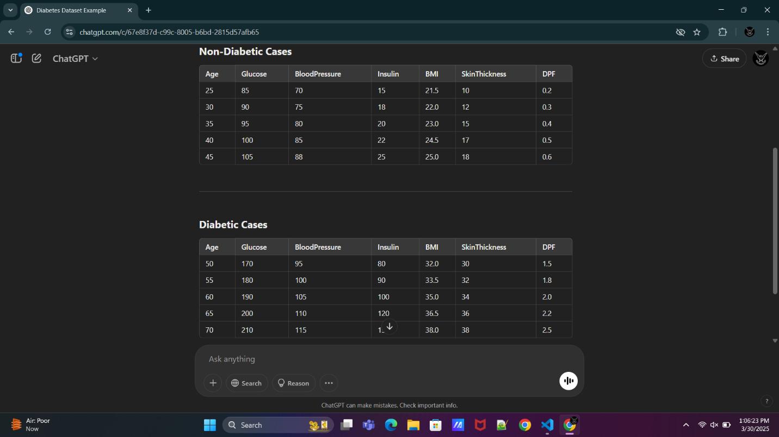

Age | Glucose | BloodPressure | Insulin | BMI | SkinThickness | DPF | Outcome

55 | 180 | 95 | 150 | 35.0 | 30 | 1.2 | 1

25 | 90 | 65 | 20 | 22.0 | 15 | 0.3 | 0

60 | 200 | 100 | 180 | 38.5 | 35 | 1.5 | 1

28 | 85 | 70 | 25 | 21.5 | 18 | 0.2 | 0

50 | 170 | 90 | 130 | 34.0 | 28 | 1.0 | 1

Age | Glucose | BloodPressure | Insulin | BMI | SkinThickness | DPF | Outcome

45 | 180 | 85 | 150 | 35.4 | 25 | 0.9 | 1

50 | 195 | 90 | 200 | 38.2 | 32 | 1.2 | 1

25 | 90 | 65 | 80 | 22.5 | 18 | 0.4 | 0

30 | 85 | 70 | 85 | 24.0 | 20 | 0.3 | 0

55 | 200 | 95 | 250 | 40.1 | 35 | 1.5 | 1

